# Lab 3: Create an Azure Stream Analytics instance

In this lab you will provision an Azure Stream Analytics instance.

In this lab the following actions will be performed:

* Create Azure Resource Group
* Create a Stream Analytics instance
* Cleanup (Optional)

## What you will need:

* Microsoft Azure Account
* Azure Resource Group

## Create Azure Resource Group if you do not have one already

If you already have an existing Resource Group, you can skip this step.

In this step an Azure Resource Group will be created. An Azure Resource group can be used as a container to group resources.

“A resource group is a container that holds related resources for an application. The resource group could include all of the resources for an application, or only those resources that are logically grouped together. You can decide how you want to allocate resources to resource groups based on what makes the most sense for your organization.”

1. Navigate to the Azure Portal (<https:///portal.azure.com>).
2. Click on: Resource groups
3. In the resource groups blade click on “Add”

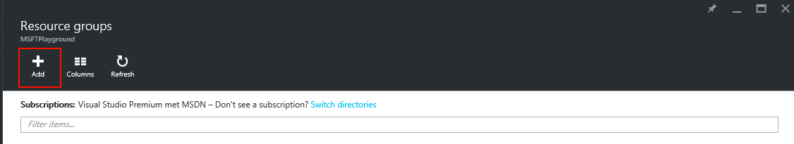

1. In the blade that appears fill in the right information and select your default location:

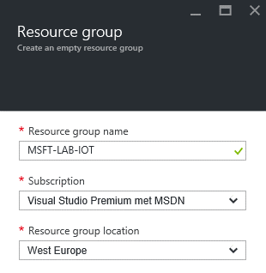

1. Click on “Create” to create the resource group.

## Create a Stream Analytics instance

In this step an Stream Analytics instance will be created.

1. Open the Azure Portal (<https://portal.azure.com>)
2. Click on: Resource groups > Your Resource group.
3. In the blade of your resource group click on “Add”

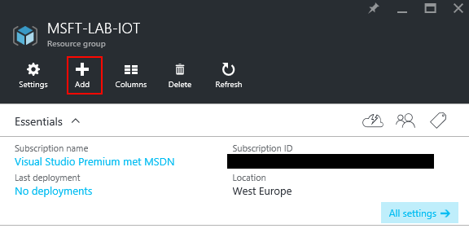

1. In the blade that appears search for “Stream Analytics job” and click on the first result.

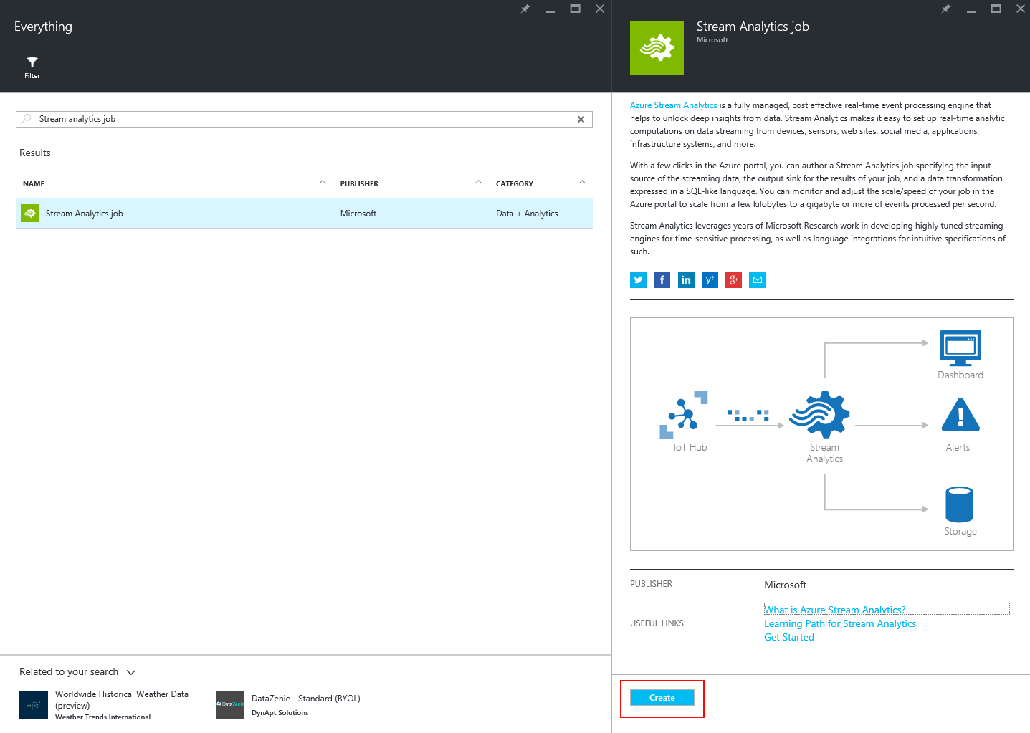

1. Again a new blade will be opened. In this blade you have to enter the properties of the Stream Analytics Job.

|  |  |  |
| --- | --- | --- |
| Property | Description | Information |
| Job Name | The name of the IoT hub | You can pick any name you want. It will be validated when entering the text. |
| Subscription | The Azure subscription where in the IoT hub needs to be created | By default you only have one subscription. If you have multiple subscriptions select the correct one. |
| Resource group | The container where in you want to create the IoT hub | Use “Use existing” to create it in the resource group created in the previous step. |
| Location | The location to provision the IoT hub in. | By default use West Europe. If you have selected the “preview” feature choose your own location for example “North-Europe”. |

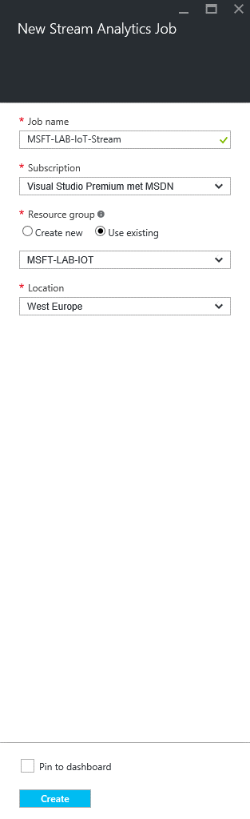

1. Click on “Create” to create the Stream Analytics job.

## Cleanup.

The following actions will delete all resources created within this Lab, if you want to keep the resources you can skip this step.

1. Navigate to the Azure Portal (<https://portal.azure.com>).
2. Click on: Resource group > Your Resource Group you created for this Lab
3. In the top bar click on: “Delete”.